Artifex Press, a publisher of digital catalogues raisonnés, is excited to announce we are a vendor within JISC Collections. We invite you to a webinar and free trial access below.
JISC Collections provides a 15% discount off the retail price for the life of the term across all bands and limits the annual rise to below 3%. See JISC Collection announcement: JISC
Published Catalogues Include
December 2017

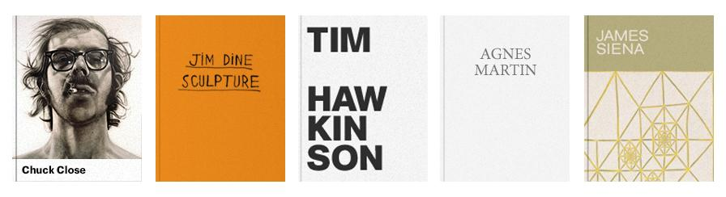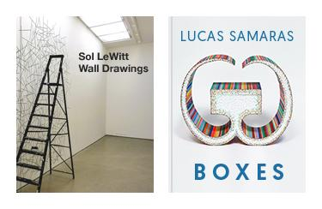

WEBINAR – All attendees will be offered a free 30-day trial access for your institution.
Please join James Whittaker, Director Sales and Marketing for an introductory webinar and preview of the forthcoming Sol LeWitt Wall Drawings catalogue raisonné:
Tuesday, December 19th at 1 p.m. GMT. Please register here: ARTIFEX PRESS WEBINAR
Or
Thursday, January 11th at 1 p.m. GMT. Please register here: ARTIFEX PRESS WEBINAR 2
If the webinar time is not convenient for you, please feel free to request a demonstration and free trial access by writing to James Whittaker, Director, Sales and Marketing, at: jwhittaker@artifexpress.com.

“Artifex Press maximizes the capabilities of the digital media publishing platform to offer the scholarly art audience a powerful new vision for the contemporary catalogue raisonne. Unlike printed catalogues raisonnes, Artifex Press catalogues are updated to incorporate new content. Users fully search or sort the complete output of an artist by date, medium, theme, location, or other data elements, providing new insights into the output of the artist. The addition of streamed media of the artist at work or in the interview setting provides valuable primary source material to the student and scholar alike. I highly recommend Artifex Press for serious academic art programs and museums with works by the artists represented in the Artifex corpus." - Margaret D. Ericson|Arts Librarian and Copyright Liaison|Bixler Art and Music Library|Colby College Libraries

