Report submitted by Alexandra Duncan, Assistant Academic Support Librarian (Fashion, Textiles and Material Futures), Central Saint Martins, University of the Arts London (UAL)
Recipient of the 2018 ARLIS/UK & Ireland Travel & Study Fund

Despite having had various brainwaves of how I could use an ARLIS Travel and Study fund I’d never before managed to put a formal proposal in. However, having attended the ARLIS/NA conference in 2017 in New Orleans as the recipient of a Kress Award, and found it to be a remarkably worthwhile experience, I was keen to attend again. Of course the location being New York helped, but I thought I could make things interesting and attend as a presenter. Although the initial deadline for conference submissions passed much earlier than I expected I was contacted by one of the members of the ARLIS/NA Fashion, Textile and Costume Librarians Special Interest Group (FTC SIG) that I had finally met in person the previous year (after a number of years of online correspondence). She wanted to propose a specialist panel of FTC speakers and was putting the feelers out to interested parties. So I proposed speaking on an information literacy project I’d devised whilst on a secondment at the London College of Fashion Library, and was one of six potential panellists.
Luckily our panel proposal was accepted and there was huge excitement (from us) at this being the first time a fashion themed panel would be featured at the conference. Even luckier for me ARLIS/UK consented to fund me £800 towards the cost of attending. My institution UAL contributed a further £200 and the rest came from my own funds. Yes, attending ARLIS/NA is no cheap excursion. Making a number of budgetary decisions like staying in an Airbnb room in Long Island City helped stretch the funding further.
For those unfamiliar with the ARLIS/NA Conference I should stress that it’s a little different to the UK one. You pre-register for the sessions you are interested in, as they have multiple speakers on at the same time- all the time. There are no sessions at any point where everyone is in the same room together. Possibly because there are no rooms big enough (there were almost 1000 attendees at the New York Conference). The only exception to this is the keynote speaker at the closing reception which is held elsewhere. It is an industrial operation. So, in a departure from the usual order of events my conference kicked off on the Monday morning with a tour of The Irene Lewisohn Costume Reference Library at the Met Museum. The wonderful Julie Le, Costume Institute Librarian (and fellow FTC panellist) introduced us to their fantastic collections after an introductory talk on the history of the institute by one of their curators. I was happy to see so many of the same items we hold in our fashion collections at Central Saint Martins, but was of course introduced to a few treasures we definitely do not have… It was also great to see another familiar face.
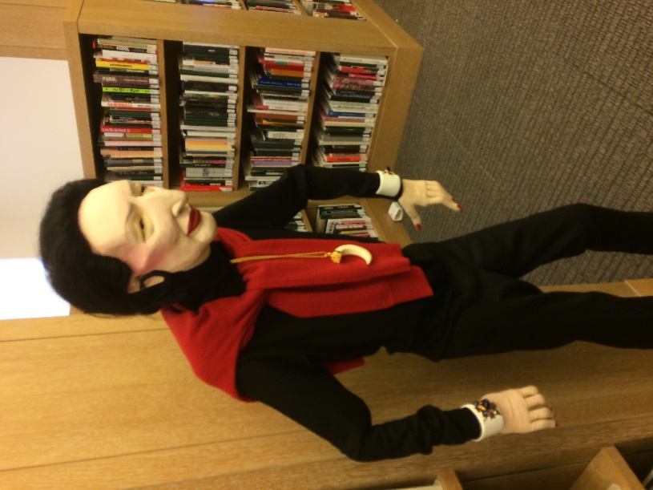
Figure 1: Diana Vreeland. Photo credit: Alex Duncan
After that it was time to attend some actual conference sessions. I’m always inspired by the breadth and depth of experience on display there, and one thing I think works well is having a panel of speakers for each session (generally for 15mins or so, but sometimes a little shorter or longer) rather than hearing about one project for 45mins. This gives a great overview of what everyone is up to professionally. I believe it also encourages a wider variety of people to submit proposals. It’s also great to be able to shape your own programme as you really can create a bespoke experience; I was particularly on the lookout for sessions related to information literacy projects, and I certainly found some.
Monday evening came quickly and it was time for the conference reception- an intimate affair of 900 or so attendees milling around the Hilton ballroom. Clutching my free drink token and keeping an eye out for any passing canapes I happened to bump into fellow UK librarian Eleanor Gawne, one of this year’s Kress recipients, and yet another UK librarian I recognised. It was good to touch base with some familiar faces. One thing I’ve gradually realised about the ARLIS/NA is that it’s made up of chapters- defined by geographic delineations, each one of which is often the equivalent size or even larger than the whole of ARLIS/UK. It’s not so much that everyone knows everyone, as it’s far too big for that, but the room generally divides into chapters and special interest groups.
Tuesday dawned, and with it a full day of interesting content- ranging from more information literacy case studies, to in-library makerspaces, practice-based research and innovative library spaces. Finding good lunch options nearby was hit and miss, Midtown is probably not the best location for independent options, but the weather was fair and I couldn’t argue with having a sandwich on a bench in Central Park with the sun shining while a blizzard hit London.
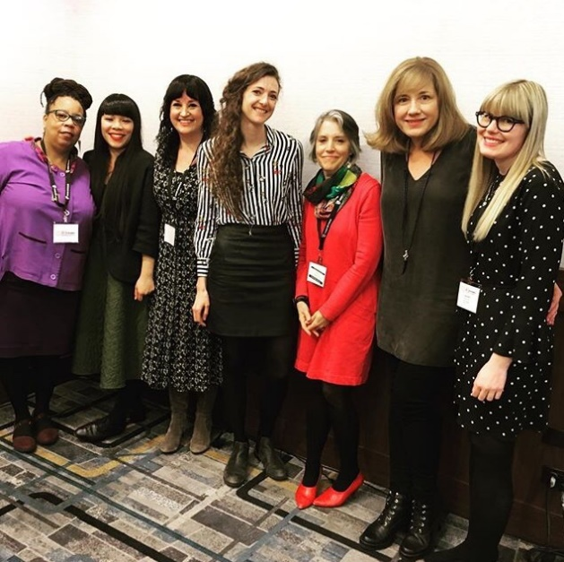
Wednesday was a demanding schedule. I attended a full morning of sessions and the FTC SIG met in the afternoon to deliver our presentations, with a good turnout of about 40-50 attendees. We delivered a fairly diverse array of presentations, covering everything from social media, serials cataloguing, museum library spaces to information literacy- all with a fashion/ textile/ costume focus of course. I was heartened by the interest of the audience, reflected in their probing questions, and swapped details with a number of new faces so we could continue discussions, particularly around the ARLIS/NA work on updating their information competencies. There immediately followed the FTC SIG AGM and a focus group led by the Bloomsbury reps on their new Bloomsbury Fashion Central platform. It’s always good to see the Bloomsbury folk, especially in somewhat nicer surroundings than our previous meeting- a windowless room in Elephant and Castle.
Figure 2: The FTC SIG panel. Photo credit: Lauren Gavin

From there it was straight on to the end of conference keynote and reception at the Cathedral of St John the Divine in Morningside Heights. A stunning venue in which keynote speaker Paul Chan spoke engagingly on his personal experience of libraries and arts publishing. Also a very nice place to enjoy a glass of wine and take stock of a successful conference experience.
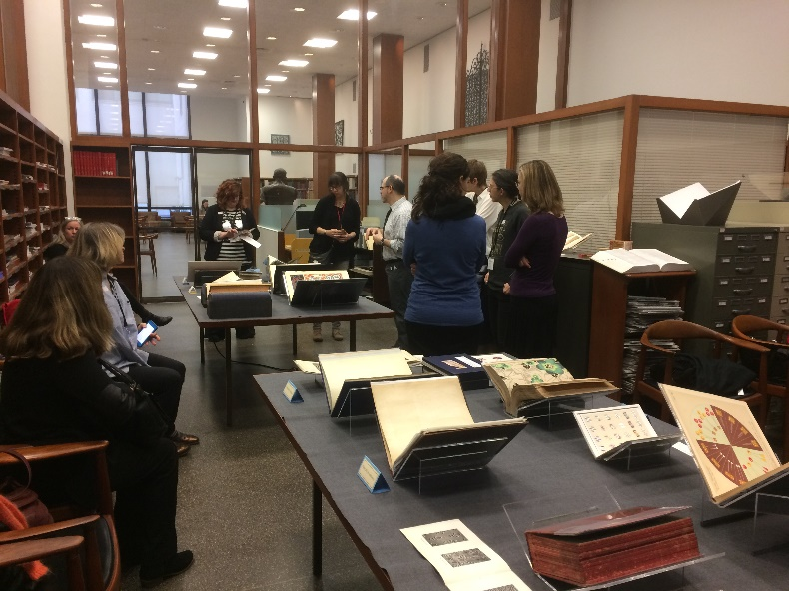
My conference properly ended the following day after attending a visit of the Thomas J. Watson Library at the Met Museum. We had a tour of their library and conservation areas before a fabulous introduction to some of their special collections by Jared Ash, Librarian for Special Collections, Russian & Slavic languages. I couldn’t think of a better way to end the conference. As ever, I was in awe of the generosity and openness of the international art librarian community. Every library I visited couldn’t have been happier to receive us and couldn’t have made us feel more comfortable. I hope to return the favour!
Figure 3: The Thomas J. Watson Library. Photo credit: Alex Duncan

